Nepal College of Information Technology
Balkumari lalitpur
Assessment Exam Fall Semester 2008

Program : IT Semester: I
Time : 3hrs Year : II
Level: Bachelor Full marks: 100

Electronic Circuits-I

1 a) Why Common Collector configuration amplifier is also called emitter follower? Verify your answer with the help of circuit diagram and necessary derivation. (7)
b) For the following Darlington amplifier. Determine (a) the overall gain; (b) the a.c. emitter diode resistance for each transistor; (c) total input resistance; and (d) the overall voltage gain. (8)
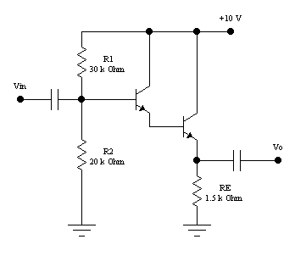
β₁=150
β₂=100
2 a) What do you mean by Miller-Effect capacitance? Explain its effect in high frequency response of an inverting amplifier with necessary derivations. (1+6)
b) Explain Class B operation using complementary push-pull configuration. What do you mean by cross-over distortion? How would you remove it. (5+3)

3 a) With the help of equivalent circuit diagram, derive the expression for input and output resistance of current shunt feedback amplifier. (7)
b) What are the conditions for oscillation? Show that the feedback ratio ( |β| ) must be 1/ 29 to sustain oscillation in RC- Phase shift Oscillator. (1+7)
4 a) A Hartley oscillator is designed with L₁ = 5 mH, L2 = 30 μH and a variable capacitance. Determine the range of capacitance values, if the frequency of oscillation is varied between 920 and 1960 kHz.

OR
The class A amplifier shown below is biased at V_{CE} = 12V. The output voltage is the maximum possible without distortion. Find
- The average power from dc supply. (7)
- The average power delivered to load.
- The efficiency.
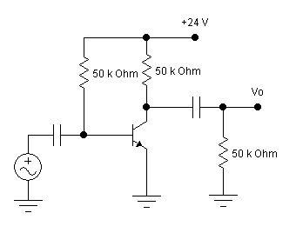
b) What are the non-ideal properties of Op-Amp? Explain its application as a differentiator with necessary derivations. (4+4)

5 a) What do you mean by Multivibrator? Draw any one Multivibrator circuit and explain its operation. (1+6)
b) Derive the output expression of 8-bit, 2-2R ladder type DAC when LSB and MSB are on condition, in-terms of V_{ref}. Why it is advantageous than weighted resistor type DAC? (7+1)

OR
a) Design Op-Amp circuit to produce the following output: V_{o} = 0.3V₁ + 5V₂ – 3.1V₃. Where V_{o} is the output and V₁, V₂, V₃ are three inputs. (7)
b) What is the effect of Bypass capacitor in gain of a common emitter amplifer? Explain with necessary derivations. (8)

6 a) Draw and explain the working principle of integrator type ADC converter. (7)
b) Why rectification is necessary? Find out the efficiency and ripple factor of fullwave bridge rectifier.

OR
6. b) What do you mean by regulated power supplies? Draw any regulated circuit and explain its operation. (8)

7. Write short notes on any two. (2x5)
- Schmitt trigger.
- Effect of negative feedback on noise.
- Crystal oscillator.
- Power dissipation and heat sinks.

